AHMET YESEVİ ÜNİVERSİTESİ

BİLGİSAYAR MÜHENDİSLİĞİ LİSANS

TBML - 304
Veritabanı Yönetim Sistemleri

HAZIRLAYAN
HASAN AYGIR - 142132079

Öğretim Görevlisi
Yrd. Doç. Dr. Battal GÖLDAĞ

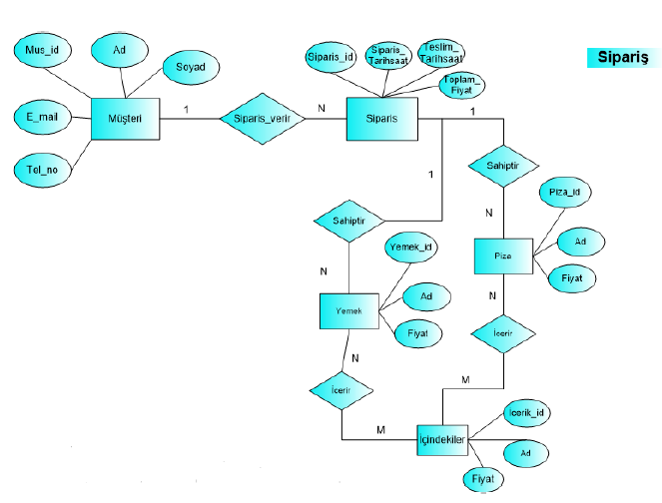
- Varlıkları Tablolara, Nitelikleri Tabloların Sütunlarına Dönüştürünüz.
Primary Key
Foreign Key
Müşteri: (Mus_Id, Ad, Soyad, Tel_No, E_Mail )
Sipariş: (Siparis_Id, Siparis_TarihSaat, Teslim_TarihSaat, Toplam_Fiyat, Musteri_Id )
Yemek: (Yemek_Id, Ad, Fiyat )
Piza: (Piza_Id, Ad, Fiyat )
İçindekiler: (Icerik_Id, Ad, Fiyat )
Piza_İçindekiler: (Id, Piza_Id, Icerik_Id )
Piza_Siparişleri: (Id, Siparis_Id, Piza_Id )
Yemek_İçindekiler: (Id, Icerik_Id, Yemek_Id )
Yemek_Siparişleri: ( Id, Siparis_Id, Yemek_Id)

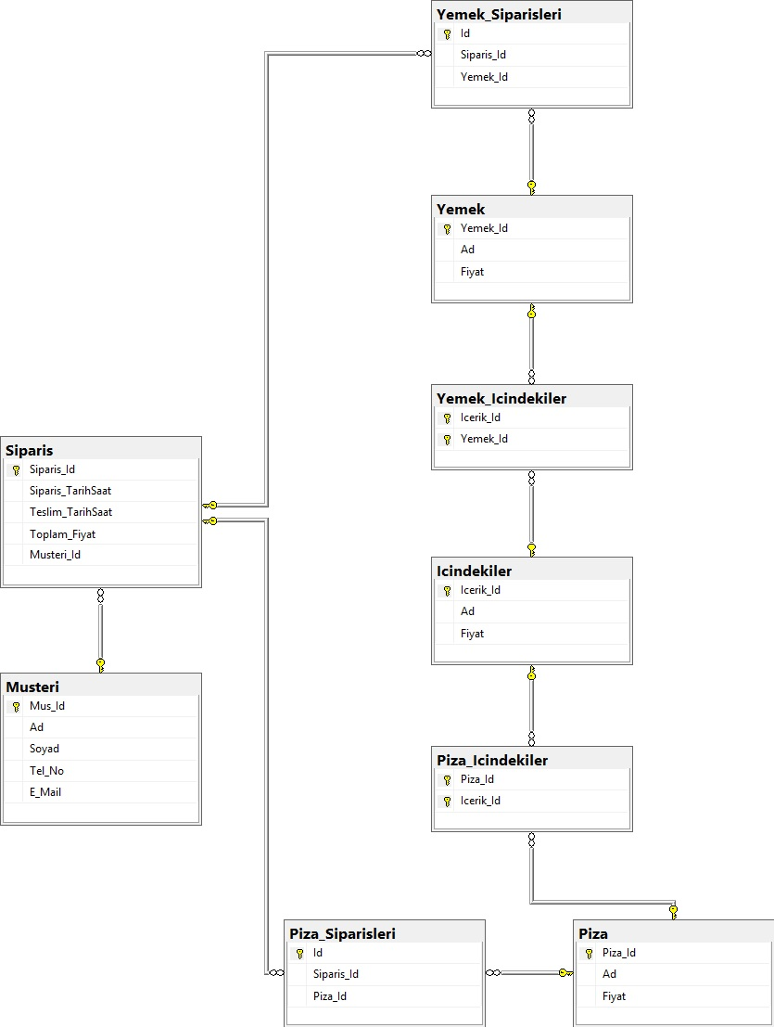

b) Birincil (Primary Key) ve Dış (Foreign Key) Anahtarları Belirleyiniz.
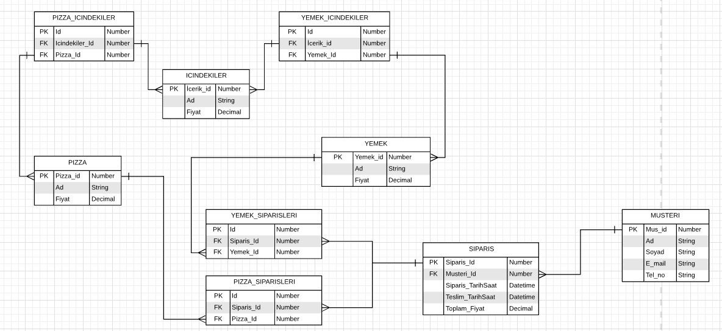
-PK= Primary Key (Birincil Anahtar) -FK= Foreign Key (Dış Anahtar)

c) SQL komutları kullanarak veri tabanını, tabloları oluşturunuz ve kısıtlayıcıları (Primary Key, Foreign Key) tanımlayınız

USE [master]
GO

/****** Object: Database [SIPARIS] Script Date: 11.12.2018 20:30:24 ******/
CREATE DATABASE [SIPARIS]
CONTAINMENT = NONE
ON PRIMARY
( NAME = N'SIPARIS', FILENAME = N'C:\Program Files\Microsoft SQL Server\MSSQL14.MSSQLSERVER\MSSQL\DATA\SIPARIS.mdf' , SIZE = 8192KB , MAXSIZE = UNLIMITED, FILEGROWTH = 65536KB )
LOG ON
( NAME = N'SIPARIS_log', FILENAME = N'C:\Program Files\Microsoft SQL Server\MSSQL14.MSSQLSERVER\MSSQL\DATA\SIPARIS_log.ldf' , SIZE = 8192KB , MAXSIZE = 2048GB , FILEGROWTH = 65536KB )
GO

USE [SIPARIS]
GO

/****** Object: Table [dbo].[Icindekiler] Script Date: 11.12.2018 20:30:24 ******/
CREATE TABLE [dbo].[Icindekiler](
[Icerik_Id] [bigint] IDENTITY(1,1) NOT NULL,
[Ad] [nvarchar](max) NOT NULL,
[Fiyat] [money] NOT NULL,
CONSTRAINT [PK_Icindekiler] PRIMARY KEY CLUSTERED
(
[Icerik_Id] ASC
)WITH (PAD_INDEX = OFF, STATISTICS_NORECOMPUTE = OFF, IGNORE_DUP_KEY = OFF, ALLOW_ROW_LOCKS = ON, ALLOW_PAGE_LOCKS = ON) ON [PRIMARY]
) ON [PRIMARY] TEXTIMAGE_ON [PRIMARY]
GO

/****** Object: Table [dbo].[Musteri] Script Date: 11.12.2018 20:30:25 ******/
CREATE TABLE [dbo].[Musteri](
[Mus_Id] [bigint] IDENTITY(1,1) NOT NULL,
[Ad] [nvarchar](50) NOT NULL,
[Soyad] [nvarchar](100) NOT NULL,
[Tel_No] [nvarchar](25) NOT NULL,
[E_Mail] [nvarchar](100) NOT NULL,
CONSTRAINT [PK_Musteri] PRIMARY KEY CLUSTERED
(
[Mus_Id] ASC
)WITH (PAD_INDEX = OFF, STATISTICS_NORECOMPUTE = OFF, IGNORE_DUP_KEY = OFF, ALLOW_ROW_LOCKS = ON, ALLOW_PAGE_LOCKS = ON) ON [PRIMARY],
CONSTRAINT [IX_Musteri] UNIQUE NONCLUSTERED
(
[E_Mail] ASC
)WITH (PAD_INDEX = OFF, STATISTICS_NORECOMPUTE = OFF, IGNORE_DUP_KEY = OFF, ALLOW_ROW_LOCKS = ON, ALLOW_PAGE_LOCKS = ON) ON [PRIMARY]
) ON [PRIMARY]
GO

/****** Object: Table [dbo].[Piza] Script Date: 11.12.2018 20:30:25 ******/
CREATE TABLE [dbo].[Piza](
[Piza_Id] [bigint] IDENTITY(1,1) NOT NULL,
[Ad] [nvarchar](250) NOT NULL,
[Fiyat] [money] NOT NULL,
CONSTRAINT [PK_Piza] PRIMARY KEY CLUSTERED
(
[Piza_Id] ASC
)WITH (PAD_INDEX = OFF, STATISTICS_NORECOMPUTE = OFF, IGNORE_DUP_KEY = OFF, ALLOW_ROW_LOCKS = ON, ALLOW_PAGE_LOCKS = ON) ON [PRIMARY]
) ON [PRIMARY]
GO

/****** Object: Table [dbo].[Piza_Icindekiler] Script Date: 11.12.2018 20:30:25 ******/
CREATE TABLE [dbo].[Piza_Icindekiler](
[Piza_Id] [bigint] NOT NULL,
[Icerik_Id] [bigint] NOT NULL,
CONSTRAINT [PK_Piza_Icindekiler] PRIMARY KEY CLUSTERED
(
[Piza_Id] ASC,
[Icerik_Id] ASC
)WITH (PAD_INDEX = OFF, STATISTICS_NORECOMPUTE = OFF, IGNORE_DUP_KEY = OFF, ALLOW_ROW_LOCKS = ON, ALLOW_PAGE_LOCKS = ON) ON [PRIMARY]
) ON [PRIMARY]
GO

/****** Object: Table [dbo].[Piza_Siparisleri] Script Date: 11.12.2018 20:30:25 ******/
CREATE TABLE [dbo].[Piza_Siparisleri](
[Id] [bigint] IDENTITY(1,1) NOT NULL,
[Siparis_Id] [bigint] NOT NULL,
[Piza_Id] [bigint] NOT NULL,
CONSTRAINT [PK_Piza_Siparisleri] PRIMARY KEY CLUSTERED
(
[Id] ASC
)WITH (PAD_INDEX = OFF, STATISTICS_NORECOMPUTE = OFF, IGNORE_DUP_KEY = OFF, ALLOW_ROW_LOCKS = ON, ALLOW_PAGE_LOCKS = ON) ON [PRIMARY]
) ON [PRIMARY]
GO

/****** Object: Table [dbo].[Siparis] Script Date: 11.12.2018 20:30:25 ******/
CREATE TABLE [dbo].[Siparis](
[Siparis_Id] [bigint] IDENTITY(1,1) NOT NULL,
[Siparis_TarihSaat] [datetime] NOT NULL,
[Teslim_TarihSaat] [datetime] NULL,
[Toplam_Fiyat] [money] NOT NULL,
[Musteri_Id] [bigint] NOT NULL,
CONSTRAINT [PK_Siparis] PRIMARY KEY CLUSTERED
(
[Siparis_Id] ASC
)WITH (PAD_INDEX = OFF, STATISTICS_NORECOMPUTE = OFF, IGNORE_DUP_KEY = OFF, ALLOW_ROW_LOCKS = ON, ALLOW_PAGE_LOCKS = ON) ON [PRIMARY]
) ON [PRIMARY]
GO

/****** Object: Table [dbo].[Yemek] Script Date: 11.12.2018 20:30:25 ******/
CREATE TABLE [dbo].[Yemek](
[Yemek_Id] [bigint] IDENTITY(1,1) NOT NULL,
[Ad] [nvarchar](250) NULL,
[Fiyat] [money] NULL,
CONSTRAINT [PK_Yemek] PRIMARY KEY CLUSTERED
(
[Yemek_Id] ASC
)WITH (PAD_INDEX = OFF, STATISTICS_NORECOMPUTE = OFF, IGNORE_DUP_KEY = OFF, ALLOW_ROW_LOCKS = ON, ALLOW_PAGE_LOCKS = ON) ON [PRIMARY]
) ON [PRIMARY]
GO

/****** Object: Table [dbo].[Yemek_Icindekiler] Script Date: 11.12.2018 20:30:25 ******/
CREATE TABLE [dbo].[Yemek_Icindekiler](
[Icerik_Id] [bigint] NOT NULL,
[Yemek_Id] [bigint] NOT NULL,
CONSTRAINT [PK_Yemek_Icindekiler] PRIMARY KEY CLUSTERED
(
[Icerik_Id] ASC,
[Yemek_Id] ASC
)WITH (PAD_INDEX = OFF, STATISTICS_NORECOMPUTE = OFF, IGNORE_DUP_KEY = OFF, ALLOW_ROW_LOCKS = ON, ALLOW_PAGE_LOCKS = ON) ON [PRIMARY]
) ON [PRIMARY]
GO

/****** Object: Table [dbo].[Yemek_Siparisleri] Script Date: 11.12.2018 20:30:25 ******/

CREATE TABLE [dbo].[Yemek_Siparisleri](
[Id] [bigint] IDENTITY(1,1) NOT NULL,
[Siparis_Id] [bigint] NOT NULL,
[Yemek_Id] [bigint] NOT NULL,
CONSTRAINT [PK_Yemek_Siparisleri] PRIMARY KEY CLUSTERED
(
[Id] ASC
)WITH (PAD_INDEX = OFF, STATISTICS_NORECOMPUTE = OFF, IGNORE_DUP_KEY = OFF, ALLOW_ROW_LOCKS = ON, ALLOW_PAGE_LOCKS = ON) ON [PRIMARY]
) ON [PRIMARY]
GO

ALTER TABLE [dbo].[Siparis] ADD CONSTRAINT [DF_Siparis_Siparis_TarihSaat] DEFAULT (getdate()) FOR [Siparis_TarihSaat]
GO

ALTER TABLE [dbo].[Piza_Icindekiler] WITH CHECK ADD CONSTRAINT [FK_Piza_Icindekiler_Icindekiler] FOREIGN KEY([Icerik_Id])
REFERENCES [dbo].[Icindekiler] ([Icerik_Id])
GO

ALTER TABLE [dbo].[Piza_Icindekiler] CHECK CONSTRAINT [FK_Piza_Icindekiler_Icindekiler]
GO

ALTER TABLE [dbo].[Piza_Icindekiler] WITH CHECK ADD CONSTRAINT [FK_Piza_Icindekiler_Piza] FOREIGN KEY([Piza_Id])
REFERENCES [dbo].[Piza] ([Piza_Id])
GO

ALTER TABLE [dbo].[Piza_Icindekiler] CHECK CONSTRAINT [FK_Piza_Icindekiler_Piza]
GO

ALTER TABLE [dbo].[Piza_Siparisleri] WITH CHECK ADD CONSTRAINT [FK_Piza_Siparisleri_Piza] FOREIGN KEY([Piza_Id])
REFERENCES [dbo].[Piza] ([Piza_Id])
GO

ALTER TABLE [dbo].[Piza_Siparisleri] CHECK CONSTRAINT [FK_Piza_Siparisleri_Piza]
GO

ALTER TABLE [dbo].[Piza_Siparisleri] WITH CHECK ADD CONSTRAINT [FK_Piza_Siparisleri_Siparis] FOREIGN KEY([Siparis_Id])
REFERENCES [dbo].[Siparis] ([Siparis_Id])
GO

ALTER TABLE [dbo].[Piza_Siparisleri] CHECK CONSTRAINT [FK_Piza_Siparisleri_Siparis]
GO

ALTER TABLE [dbo].[Siparis] WITH CHECK ADD CONSTRAINT [FK_Siparis_Musteri] FOREIGN KEY([Musteri_Id])
REFERENCES [dbo].[Musteri] ([Mus_Id])
GO

ALTER TABLE [dbo].[Siparis] CHECK CONSTRAINT [FK_Siparis_Musteri]
GO

ALTER TABLE [dbo].[Yemek_Icindekiler] WITH CHECK ADD CONSTRAINT [FK_Yemek_Icindekiler_Icindekiler] FOREIGN KEY([Icerik_Id])
REFERENCES [dbo].[Icindekiler] ([Icerik_Id])
GO

ALTER TABLE [dbo].[Yemek_Icindekiler] CHECK CONSTRAINT [FK_Yemek_Icindekiler_Icindekiler]
GO

ALTER TABLE [dbo].[Yemek_Icindekiler] WITH CHECK ADD CONSTRAINT [FK_Yemek_Icindekiler_Yemek] FOREIGN KEY([Yemek_Id])
REFERENCES [dbo].[Yemek] ([Yemek_Id])
GO

ALTER TABLE [dbo].[Yemek_Icindekiler] CHECK CONSTRAINT [FK_Yemek_Icindekiler_Yemek]
GO

ALTER TABLE [dbo].[Yemek_Siparisleri] WITH CHECK ADD CONSTRAINT [FK_Yemek_Siparisleri_Siparis] FOREIGN KEY([Siparis_Id])
REFERENCES [dbo].[Siparis] ([Siparis_Id])
GO

ALTER TABLE [dbo].[Yemek_Siparisleri] CHECK CONSTRAINT [FK_Yemek_Siparisleri_Siparis]
GO

ALTER TABLE [dbo].[Yemek_Siparisleri] WITH CHECK ADD CONSTRAINT [FK_Yemek_Siparisleri_Yemek] FOREIGN KEY([Yemek_Id])
REFERENCES [dbo].[Yemek] ([Yemek_Id])
GO

ALTER TABLE [dbo].[Yemek_Siparisleri] CHECK CONSTRAINT [FK_Yemek_Siparisleri_Yemek]
GO

